Safe work method statement
Job Task Summary:  Sample collection from Brucella suis positive dogs by private veterinarians.  B suis is an important zoonotic disease. Up to 2% of people untreated die as a result of infection with Brucella suis. Feral pigs are the usual source of infection for people and it is suspected that infected dogs also pose a significant risk to humans. | This SWMS is applicable to the following worker type: |  | Persons collecting samples for B suis testing
 | SWMS completed by: |  | Kelli Johnston
 | Site: Veterinary clinics at various locations in NSW
 | Date: 21.9.15
How to complete the form:  - Discuss with relevant workers the steps, and associated hazards, risks and controls  - In the ‘Procedural steps’, list the work steps in sequence of how they will be carried out  - In the ‘Possible hazards’, list the hazards and risks for each step  - In ‘R1’ rate the risk without controls using the risk matrix (see over page) |  | - In the ‘Safety controls’ list how the hazards will be controlled and who is responsible to implement the controls  - In ‘R2’ rate the risk with controls (residual risk) using the risk matrix (see over page)  - Specify other requirements for the task  - Each person involved with this task must sign acknowledging that they have understood the steps

R1 Risk without controls R2 Risk with controls
PROCEDURAL STEP(S) | POSSIBLE HAZARD(S) | R1 | SAFETY CONTROL(S) | PERSON RESPONSIBLE | R2
Preparation for sampling | - Zoonotic infection | 2C | - Choose location which can be easily cleaned/disinfected and low people numbers and movements. If outdoors use disposable impermeable material to minimise spillage of body fluids onto ground. Perform in isolation room. Use disposable drapes to eliminate requirement to clean.  - Minimise number of people involved in procedure  - Conduct procedure at a time people are not required to be in area and allow time for settling of aerosols afterward  - All people involved in sample collection and clean up wear PPE minimum of:  - Eye protection  - P2 mask  - Disposable overalls  - Gloves  - Enclosed footwear  - Be aware of resources  - Health and safety precautions for investigating zoonotic animal diseases  - Australian Veterinary Association Guidelines for veterinary personal biosecurity at http://www.ava.com.au/biosecurity-guidelines | Private veterinarian, vet nurses and assistants | 2D
Collecting samples | - Human Brucellosis from exposure to infectious agent in blood or bodily fluids contacting mucous membranes (mouth, nose, eyes) or contact with open wound | 1C | - Pregnant women should avoid working with suspect or confirmed B suis dogs  - Cover cuts and abrasions with impermeable dressing or clothing  - Minimise creation of aerosols or splashes of bodily fluids by:  - Castration – closed method  - Hysterectomy – as for pyometra  - Dystocia/retained fetal membranes – vaginal swab or membranes directly into container  - Caesarean – swab or aspirate fluids, pup or membranes directly into container  - Urine – cystocentesis preferred. If midstream wear PPE and plan how to deal with urine on floor/ground. Assume exterior of container is contaminated.  - Wash hands thoroughly with soapy water or antiseptic after removing PPE  - Do not eat, drink or smoke while conducting collection.  - On completion of collection, before removing PPE:  - Clean and disinfect re-useable equipment by submerging in warm soapy water or disinfectant rather than using running water to ensure aerosols are not created  - Chlorine, iodine based disinfectants and Virkon S are effective if used at recommended concentration for the recommended time on clean surfaces or equipment. Hot water (60oC for 10 minutes) is also effective. Dispose of contaminated waste eg contaminated PPE using clinical waste systems (do not re-sheath needles) | Private veterinarian, vet nurses and assistants | 2D
Collecting samples | - Working with animals – injury from bites, scratches | 3B | - Assess temperament before handling and use PPE and handling tools if needed eg. Muzzle or chemical restraint.  - Do not attempt sampling if animal cannot be safely handled | Private veterinarian, vet nurses and assistants | 3D
Collecting samples | - Handling heavy loads eg large dogs causing back, muscle or joint strain | 3B | - Avoid lifting large dogs or use equipment or assistance | Private veterinarian, vet nurses and assistants | 4D
Collecting samples | - Sharps injury or infection from cuts or puncture wounds | 3B | - Ensure all equipment is sharp and in good repair  - Wear PPE (as above)  - Do not re-sheath needles, dispose directly into sharps container  - If sharps injury occurs, wash injury, apply antiseptic and seek medical advice immediately | Private veterinarian, vet nurses and assistants | 3D
Collecting samples | - Using an awkward or sustained posture causing back, muscle or joint strain | 3B | - Take regular breaks  - Share work load  - Position patient at desk height when possible  - Use well maintained equipment | Private veterinarian, vet nurses and assistants | 3D
Sending and storing samples | - Exposure of other workers to infectious agent | 2B | - Samples to be packed and consigned in accordance with the NSW Department of Primary Industries Laboratory Manual see http://www.dpi.nsw.gov.au/agriculture/vetmanual/submission  - Including specific instructions at NSW Department of Primary Industries CVO Bulletin to Veterinarians: Brucellosis (B. suis) in dogs http://www.dpi.nsw.gov.au/biosecurity/animal/humans/brucellosis-in-dogs  - Dispose of contaminated waste using clinical waste systems | Private veterinarian, vet nurses, assistants and laboratory staff | 2D
Carcase disposal | - Exposure of others to infectious agent | 2B | - Body/body parts to be placed into impervious bag and sealed. Double bag such that exterior surfaces are uncontaminated. Ensure body fluids do not spill from the bag while awaiting pick up eg in refrigerator  - If disposed on farm, burying is acceptable | Private veterinarian, vet nurses, assistants and laboratory staff | 2D

WHS RISK MATRIX | HIERARCHY OF CONTROLS
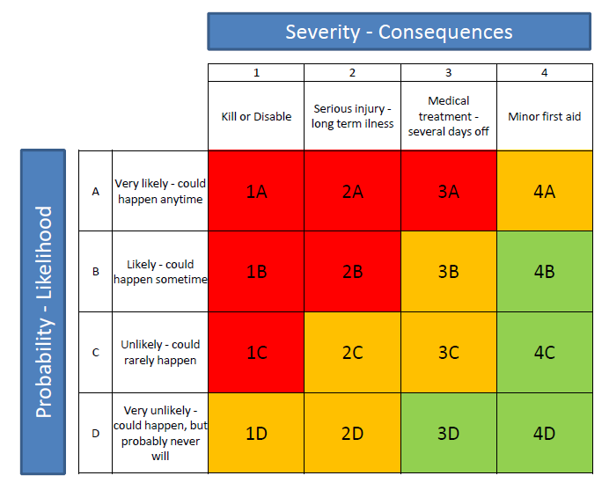 | 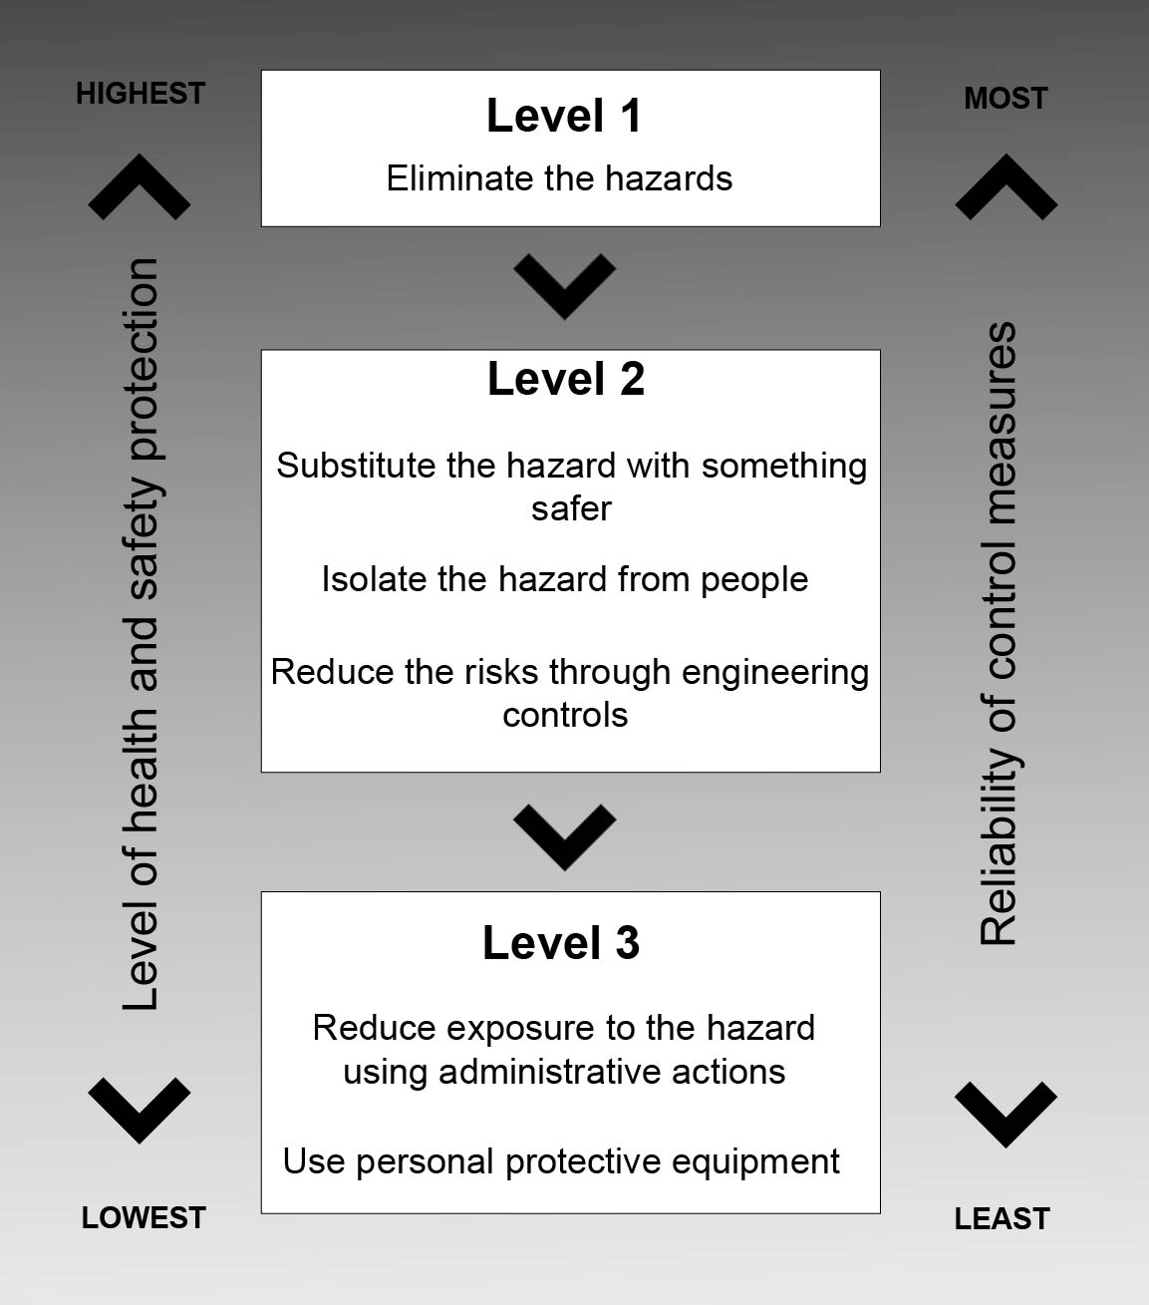

OTHER JOB REQUIREMENTS
List staff skills/competencies and licences required for safe job performance: | List items of plant/equipment/tools required:  Syringes, needles, specimen jars, swabs, body bags, antiseptic, disinfectant, cleaning equipment, contaminated waste facility, sharps container,
Relevant codes of practice, legislation standards or critical risk controls that may be applicable:  - Health and safety precautions for investigating zoonotic animal diseases  - http://www.ava.com.au/biosecurity-guidelines  - http://www.dpi.nsw.gov.au/biosecurity/animal/humans/brucellosis-in-dogs | Maintenance checks, site/workplace inspections required:
Additional approvals, certificates, WorkCover approvals/permits required e.g. confined spaces, working at heights, hot works etc: | PPE required: | Gloves | Eye protection | P2 mask
 | Overalls | Safety footwear
Has a risk assessment been completed for any work involving confined spaces, electrical work or diving work N/A

APPROVAL (Officer, Manager, Supervisor i.e. person responsible for ensuring compliance with SWMS)
Name: Manager Animal biosecurity Services and Response | Date: 19 October 2015

I HAVE READ AND UNDERSTAND THIS SAFE WORK METHOD STATEMENT
NAME | SIGNATURE | DATE |  | NAME | SIGNATURE | DATE

