Dataset: Murray Hardyhead Indicative Distribution in NSW
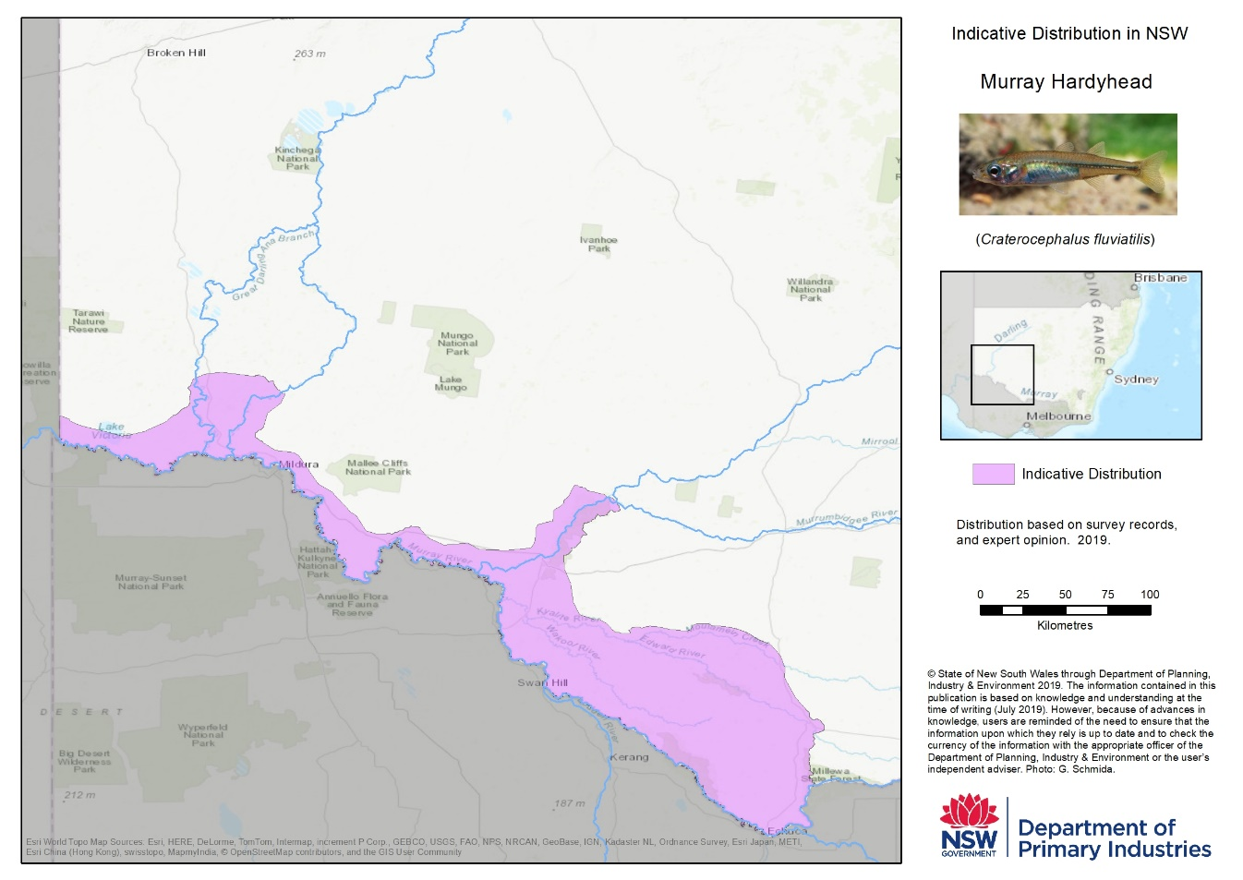
Dataset/Product Description | Craterocephalus fluviatilis is a small freshwater fish, native to the floodplains of the southern MurrayDarling Basin. They were once widespread and abundant throughout their range; however the species has suffered a serious decline in abundance and distribution, and are now considered one of the most threatened vertebrate species in Australia. Murray Hardyhead is rare in NSW and only a few isolated populations occur in Victoria and South Australia. All populations are threatened by declining water levels, habitat loss and impacts of pest fish (including Gambusia, Redfin and Carp).  It is listed as a ‘critically endangered’ species in NSW under the Fisheries Management Act 1994.  https://www.dpi.nsw.gov.au/fishing/species-protection/what-current/critically-endangered-species/murray-hardyhead.  This indicative distribution was derived from survey records and expert opinion.
Dataset Uses | The dataset has a number of primary functions including but not limited to;  - spatially representing the status of fish communities at river reach scale across NSW  - providing additional support to strategic planning frameworks to ensure they effectively integrate biodiversity considerations into planning and decision making processes
Current Status | The Murray Hardyhead Distribution in NSW dataset was produced in 2019.
Standards & Specifications | ANZLIC Metadata Profile: An Australian/New Zealand Profile of AS/NZS ISO 19115:2005, Geographic information – Metadata
Access and Licensing | The Murray Hardyhead Distribution in NSW is authored by the Department of Industry, Skills and Regional Development is licensed under a Creative Commons Attribution-NonCommercial-NoDerivatives 4.0 International License.  The Department of Industry, Skills and Regional Development asserts the right to be attributed as author of the Murray Hardyhead Distribution in NSW in the following manner:  © State of New South Wales through Department of Planning, Industry & Environment 2019.  Any derived products which are created will be required to clearly mark the date that any extractions from the NSW Industry’s Corporate Spatial Databases occurred.  All Intellectual Property which is owned by NSW Industry should only be loaded on any external cloud platforms if NSW Industry's Intellectual Property (IP) remains unchanged, maintained and preserved.
Metadata | https://www.dpi.nsw.gov.au/__data/assets/pdf_file/0007/669589/fish-communities-and-threatened-species-distributions-of-nsw.pdf
Updates | As required.
Custodian Agency & Contact | Karen Danaher  Fisheries Manager, Spatial Planning  Department of Primary industries  NSW Trade and Investment  Address: 1243 Bruxner Highway, Wollongbar NSW 2477  Ph: 02 6626 1325  Email: karen.danaher@dpi.nsw.gov.au
Aggregator(s)

Distributor(s) | Karen Danaher  Fisheries Manager, Spatial Planning  Department of Primary industries  NSW Trade and Investment  Address: 1243 Bruxner Highway, Wollongbar NSW 2477  Ph: 02 6626 1325  Email: karen.danaher@dpi.nsw.gov.au
Additional Comments

